1. University Course Registration System
Tables
- Student(StudentID, Name, DepartmentID)
- Department(DepartmentID, DepartmentName)
- Course(CourseID, CourseName, FacultyID)
- Faculty(FacultyID, FacultyName)
- Enrollment(StudentID, CourseID, Semester)
Relationship Diagram
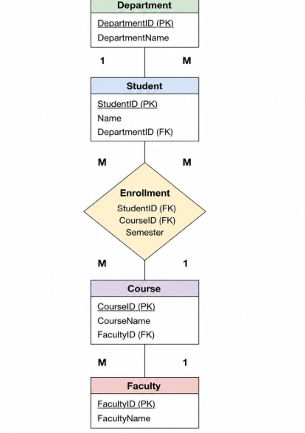
Q1. Why is the Enrollment table necessary instead of storing CourseID directly in the Student table?
Answer:
The Enrollment table is required because one student can enroll in many courses, and one course can have many students. This is a many-to-many relationship. The Enrollment table stores the relationship between students and courses without repeating information, making the database efficient and reducing redundancy.
Q2. If the university wants to track grades for each enrolled course, how would you modify the schema?
Answer:
Add a new attribute called Grade to the Enrollment table.
Modified Schema
Enrollment(StudentID, CourseID, Semester, Grade)
2. Online Shopping System
Tables
- Customer(CustomerID, Name)
- Product(ProductID, ProductName, Price)
- Order(OrderID, CustomerID, OrderDate)
- OrderDetails(OrderID, ProductID, Quantity)

Relationship Diagram
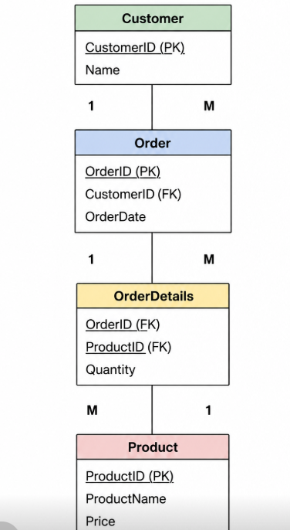
Q1. Why is the OrderDetails table required in this schema?
Answer:
The OrderDetails table is required because one order can contain multiple products, and the same product can appear in different orders. It acts as a bridge table between the Order and Product tables and stores the quantity of each product in an order.
Q2. What would happen if ProductID were stored directly in the Order table?
Answer:
If ProductID were stored directly in the Order table, each order could contain only one product. To store multiple products, duplicate order records would be required, causing data redundancy and making updates difficult.

3. Library Management System
Tables
- Member(MemberID, Name)
- Book(BookID, Title, Author)
- Issue(MemberID, BookID, IssueDate, ReturnDate)
Relationship Diagram
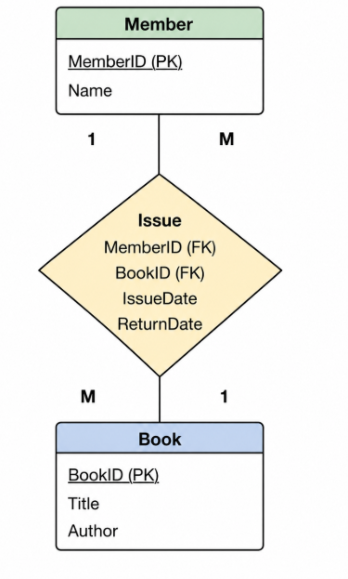
Q1. Explain the relationship between Member and Book through the Issue table.
Answer:
A member can borrow multiple books, and a book can be borrowed by different members over time. Therefore, Member and Book have a many-to-many relationship. The Issue table connects them by storing borrowing details such as IssueDate and ReturnDate.

Q2. How would you modify the schema to track overdue fines?
Answer:
A new attribute called FineAmount can be added to the Issue table.
Modified Schema
Issue(MemberID, BookID, IssueDate, ReturnDate, FineAmount)

